Title: | LIN SLAVE  LIN Slave Node Design Document V1.4

History
Issue status  (Index) | Maturity/Date  (draft/invalid/valid)  (dd-mmm-yyyy) | Author  Department | Check/Release  Department | Description
0.1 | Draft  05-Aug-15 | Gilberto Ochoa /  CES |  | Creation of the document. First draft
0.2 | Draft  06-Aug-15 | Gilberto Ochoa /  CES |  | Add Sequence Diagram
0.3 | Draft  06-Aug-15 | Gilberto Ochoa /  CES |  | Add State Machine
0.4 | Draft  06-Aug-15 | Armando Villa /  CES |  | Add General Lin System Diagram
0.5 | Draft  06-Aug-15 | Gilberto Ochoa /  CES |  | Add Conditions for State Machine
0.6 | Draft  06-Aug-15 | Armando Villa /  CES |  | Add Slave Lin System Diagram
1.0 | Review  07-Aug-15 | Jose Luis |  | Review Design File
1.1 | Draft  07-Aug-15 | Armando Villa /  CES |  | Add Test Cases Diagram
1.2 | Draft  10-Aug-15 | Gilberto Ochoa /  CES |  | Changed LIN State Machine
1.3 | Draft  10-Aug-15 | Gilberto Ochoa /  CES |  | Changed Sequence Diagram
1.4 | Draft  10-Aug-15 | Gilberto Ochoa /  CES |  | Changed General LIN System Diagram

Table of Contents
1 Purpose 3
2 Definitions and abbreviations 3
3 Realization constraints and targets 4
3.1 System Diagram 5
4 SW Component internal breakdown 6
4.1 Test Cases Diagram 6
4.1.1 Sequence Diagram 6
4.1.2 State Machine 7
4.1.3 Conditions 8
4.1.4 Function <Type> <function name> (type par 1, .., type par n) 9
4.1.5 Function <Type> <function name> (type par 1, .., type par n) 9
4.2 Macros 10
4.3 SW module global variables 11
4.4 Design solutions for general features 11
4.5 SW Component integration 11
4.5.1 Integration context / constraints 11
4.5.2 Include files 11
4.5.3 Initialization 11
4.5.4 Interrupts 12
4.5.5 Real time scheduler task 12
4.5.6 Other entry points 12

Purpose
This document describes the LIN slave node.
5 nodes are designated; 1 master node and 4 slave nodes, from which we will focus on the slave node 3 (Slave3) while the rest will be developed by other teams.
After executing the corresponding sequence of commands and specifications defined by the protocol itself, the nodes will control the On-board LEDs of the TRK-MCP5006B Freescale board to display the commands defined in the requirements document, such as ON, OFF and TOGGLING, as well as the node’s own status (enabled/disabled).

Definitions and abbreviations

Definitions
LIN_SYNCH_SYMBOL | 0x55

Abbreviations

LIN | Local interconnect Network
RX | Reception
TX | Transmission
MSTR | Master
SLV | Slave
MSG | Message
HAL | Hardware Abstraction Layer

References
N° | Document name | Reference
1 | LIN_Spec_1_3.pdf
2 | LIN_Network_Database.xlsm

Realization constraints and targets

Build a LIN slave that responds to certain IDs.

The project contains 13 different MSG ID:

Msg ID | Msg Name | Msg Data Len | Msg Publisher | Msg Subscribers | Msg Callback
CF | MSTR_CMD_ALL | 1 | MSTR | SLAVE1, SLAVE2, SLAVE3, SLAVE4 | auto
50 | MSTR_CMD_SLV1 | 1 | MSTR | SLV1 | auto
11 | MSTR_CMD_SLV2 | 1 | MSTR | SLV2 | auto
92 | MSTR_CMD_SLV3 | 1 | MSTR | SLV3 | auto
D3 | MSTR_CMD_SLV4 | 1 | MSTR | SLV4 | auto
20 | SLV1_RSP | 2 | SLV1 | MSTR | auto
61 | SLV2_RSP | 2 | SLV2 | MSTR | auto
E2 | SLV3_RSP | 2 | SLV3 | MSTR | auto
A3 | SLV4_RSP | 2 | SLV4 | MSTR | auto
F0 | SLV1_ID | 7 | SLV1 | MSTR | auto
B1 | SLV2_ID | 7 | SLV2 | MSTR | auto
32 | SLV3_ID | 7 | SLV3 | MSTR | auto
73 | SLV4_ID | 7 | SLV4 | MSTR | auto

*Messages used for and by slave 3

The project contains 5 Signal types:

Type Name | Elements…
t_slv_stat | ENABLED | DISABLED
t_cmdType | cmd_NONE | cmd_LED_on | cmd_LED_off | cmd_LED_toggling | cmd_disable_slv | cmd_enable_slv
t_LEDstat | ON | OFF | TOGGLING
t_target_active | ACTIVE | INACTIVE
t_boolean | TRUE | FALSE

Signals defined for this network.

Signal Name | Signal Msg | Signal Start Byte | Signal Start Bit | Signal Len (bits) | Signal Type | Signal Endianess
master_cmdForAll | MASTER_CMD_ALL | 0 | 0 | 4 | t_cmdType | LE
master_cmdForSlave1 | MASTER_CMD_SLV1 | 0 | 0 | 4 | t_cmdType | LE
master_cmdForSlave2 | MASTER_CMD_SLV2 | 0 | 0 | 4 | t_cmdType | LE
master_cmdForSlave3 | MASTER_CMD_SLV3 | 0 | 0 | 4 | t_cmdType | LE
master_cmdForSlave4 | MASTER_CMD_SLV4 | 0 | 0 | 4 | t_cmdType | LE
slave1_LEDstat | SLAVE1_RSP | 0 | 0 | 2 | t_LEDstat | LE
slave1_enabled | SLAVE1_RSP | 1 | 0 | 1 | t_boolean | LE
slave1_supplier | SLAVE1_ID | 0 | 0 | 8 | scalar | LE
slave1_serial | SLAVE1_ID | 1 | 0 | 48 | array | LE
slave2_LEDstat | SLAVE2_RSP | 0 | 0 | 2 | t_LEDstat | LE
slave2_enabled | SLAVE2_RSP | 1 | 0 | 1 | t_boolean | LE
slave2_supplier | SLAVE2_ID | 0 | 0 | 8 | scalar | LE
slave2_serial | SLAVE2_ID | 1 | 0 | 48 | array | LE
slave3_LEDstat | SLAVE3_RSP | 0 | 0 | 2 | t_LEDstat | LE
slave3_enabled | SLAVE3_RSP | 1 | 0 | 1 | t_boolean | LE
slave3_supplier | SLAVE3_ID | 0 | 0 | 8 | scalar | LE
slave3_serial | SLAVE3_ID | 1 | 0 | 48 | array | LE
slave4_LEDstat | SLAVE4_RSP | 0 | 0 | 2 | t_LEDstat | LE
slave4_enabled | SLAVE4_RSP | 1 | 0 | 1 | t_boolean | LE
slave4_supplier | SLAVE4_ID | 0 | 0 | 8 | scalar | LE
slave4_serial | SLAVE4_ID | 1 | 0 | 48 | array | LE

*Messages used for and by slave 3

System Diagram
General LIN System Diagrams

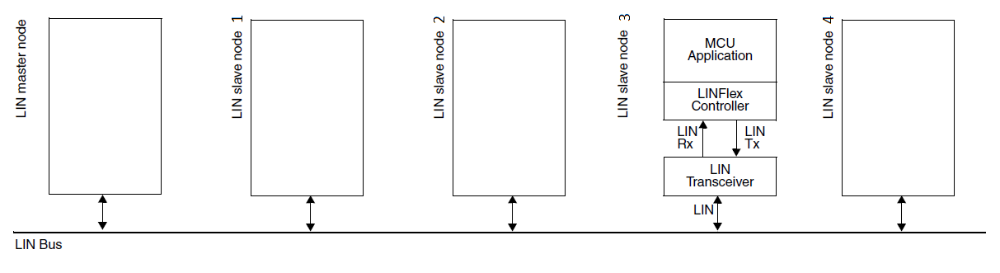

LIN Slave System Diagrams

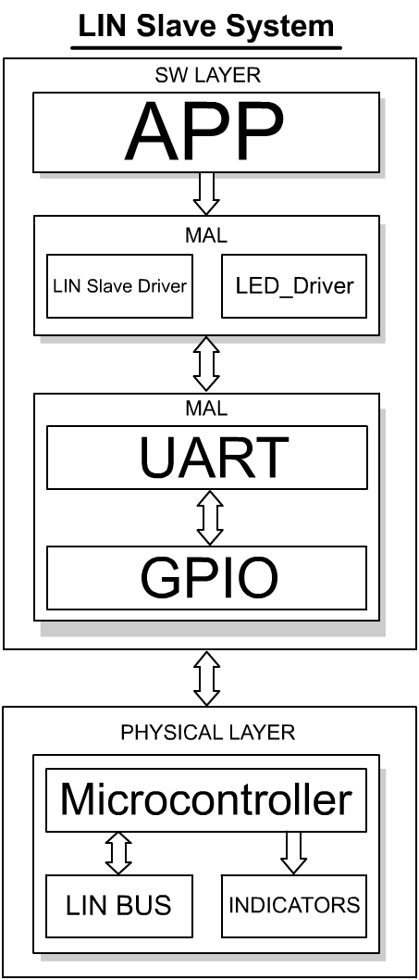

SW Component internal breakdown

Test Cases Diagram
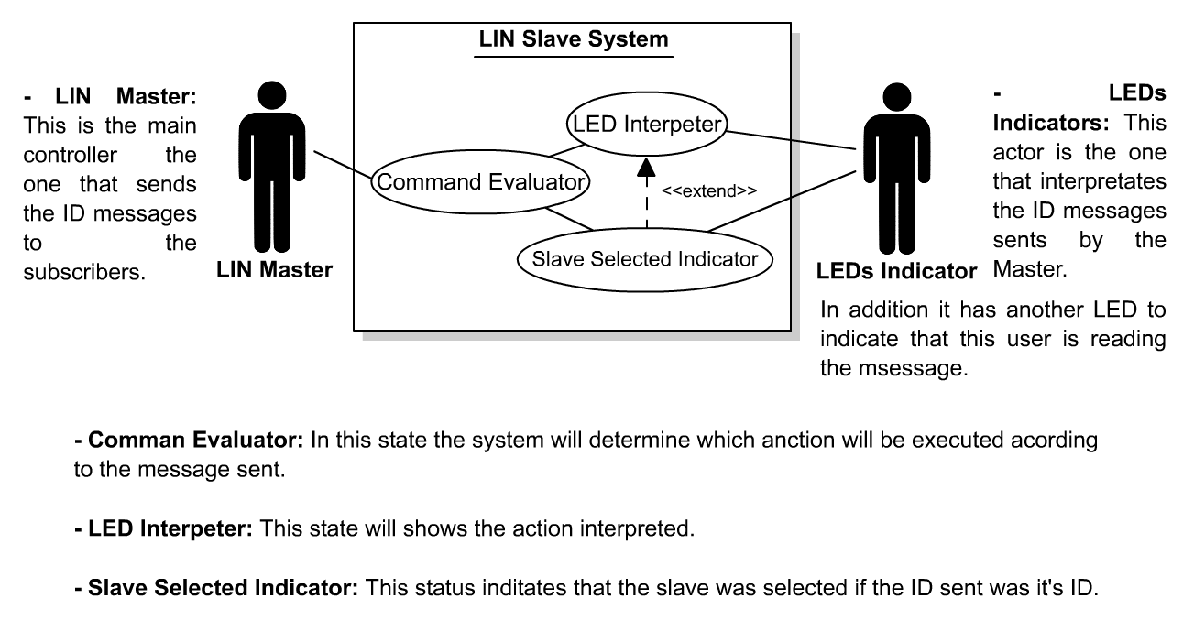

Sequence Diagram

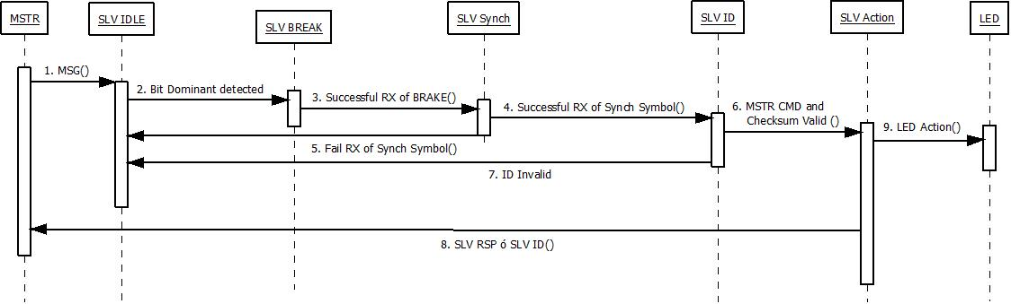

State Machine

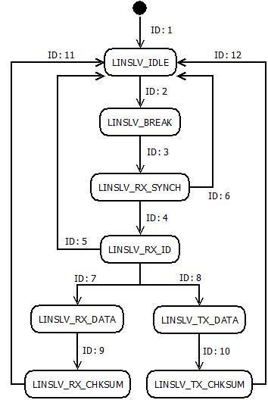

Conditions

ID | Conditions
ID: 1 | [ LINSLV _BREAK_RX == ENABLE ]
ID: 2 | [ Event == LINSLV_BREAK_DETECTED ]
ID: 3 | [ Event == LINSLV_BREAK_VALID ]
ID: 4 | [ linSlv_receivedByte() == LIN_SYNCH_SYMBOL ]
ID: 5 | [ MSTR_CMD_ID == INVALID ]
ID: 6 | [ linSlv_receivedByte() != LIN_SYNCH_SYMBOL ]
ID: 7 | [ (LIN_MSG_ID == MASTER_CMD_ALL) || (LIN_MSG_ID == MASTER_CMD_SLV3) ]
ID: 8 | [ (LIN_MSG_ID == SLAVE3_RSP) || (LIN_MSG_ID == SLAVE3_ID) ]
ID: 9 | [ All data bytes received == FINISH ]
ID: 10 | [ All data bytes to transmit == FINISH ]
ID: 11 | [ Event == LINSLV_RX_OK ]
ID: 12 | [ Event == LINSLV_TX_OK ]

Function Description and Dynamic Behavior
Provide detailed static and dynamic description of all functions of the SW Component.
Functions which are defined in other SW Components shall only be referenced in the external interface description!
The signature description shall be done inside the function header in the source code.
For each function, the following section should be copied

Function <Type> <function name> (type par 1, .., type par n)

Description | Brief description of the function behavior and useful remarks
Parameter 1  <input| output| inout> | Give an explanation if the parameter shall be checked by the user, or if a check is implemented in the function here
Parameter 2..n
Return Value
Precondition | e.g. Function can only be called in a certain state, SW component is initialized  Relation between input parameters where applicable (Input for Module Test)
Post condition | e.g. specific State change e.g. car is locked, EEPROM Values written,  Relation between output parameters where applicable
Error Conditions

Dynamic Behavior
State Chart¹, Flow Chart¹
¹ Preferred
In this document, the dynamic behavior shall be designed on an abstract level showing the principle workflow of a function. Do not show the detailed implementation to ensure that the design description can be maintained with a reasonable effort. The target is not to show the complete detailed implementation 1:1.
The detailed design shall reflect in detail what a function is doing from a black box view. The internal details are useful on an abstract, but not very detailed level.
If the function is not complex a short textual description might be sufficient and a graphical description is not needed.
Symbol and function names shall be self explaining.
The link to the implementation may be provided by using the same names as in the design or by a comment showing the full name followed by the declaration showing the implementation.

Function <Type> <function name> (type par 1, .., type par n)
Description | Brief description of the function behavior and useful remarks
Parameter 1
<input| output| inout>
Parameter 2..n
Return Value
Precondition | e.g. Function can only be called in a certain state, SW component is initialized  Relation between input parameters where applicable (Input for Module Test)
Post condition | e.g. specific State change e.g. car is locked, EEPROM Values written,  Relation between output parameters where applicable
Error Conditions

Dynamic Behavior
State Chart¹, Flow Chart¹, Nassi Shneiderman
¹ Preferred
In this document, the dynamic behavior shall be designed on an abstract level showing the principle workflow of a function. Do not show the detailed implementation to ensure that the design description can be maintained with a reasonable effort. The target is not to show the complete detailed implementation 1:1.
The detailed design shall reflect in detail what a function is doing from a black box view. The internal details are useful on an abstract, but not on a very detailed level.
Symbol and function names shall be self explanatory.
The link to the implementation may be provided by using the same name as in the design or by a comment showing the full name followed by the declaration showing the implementation.

Macros

Only complex macros shall be described here. A complex macro is longer then one line or has more then one parameter or command. A complete description of all macros shall be done by code comments.
Be aware: macros shouldn’t be part of the interface: Don’t use macros at interface level!
If you still think you need macros: document them like functions.
Internal Interfaces
For internal interaction a data flow and/or a message sequence chart shall be provided. If the Static Function Tree already contains a data flow description then just reference it

SW module global variables
Where shared variables can not be avoided, a risk analysis is mandatory.
Name | Type | Memory section | Description | Shared
Klstrg_status | T_UBYTE | NON_INIT_RAM | Status of terminal control | X

Design solutions for general features
It should describe detailed design solutions for general features of our products. i.e ”Layer Programming”

SW Component integration

Integration context / constraints
Tbd: help text

Include files
List here the necessary include files and their order,

Initialization
e.g. Sequence Chart for initialization
All function bellow shall be called on initialization
Call Order | Service | Call constraints linked to an other module
1 | BCM_Warning_Output_Init_Function | After EEPROM init

Interrupts
If described in the SW Architecture Document, just put the reference here.

Real time scheduler task
If described in the SW Architecture Document, just put the reference here.

Other entry points
Name | Service | Task level

